SCHOOL OF COMPUTER SCIENCE AND ARTIFICIAL INTELLIGENCE |  |  |  |  | DEPARTMENT OF COMPUTER SCIENCE ENGINEERING
Program Name: B. Tech |  |  |  | Assignment Type: Lab |  |  | Academic Year:2025-2026
Course Coordinator Name |  |  |  | Venkataramana Veeramsetty
Instructor(s) Name |  |  |  | Dr. V. Venkataramana (Co-ordinator)  Dr. T. Sampath Kumar  Dr. Pramoda Patro  Dr. Brij Kishor Tiwari  Dr.J.Ravichander  Dr. Mohammand Ali Shaik  Dr. Anirodh Kumar  Mr. S.Naresh Kumar  Dr. RAJESH VELPULA  Mr. Kundhan Kumar  Ms. Ch.Rajitha  Mr. M Prakash  Mr. B.Raju  Intern 1 (Dharma teja)  Intern 2 (Sai Prasad)  Intern 3 (Sowmya)  NS_2 ( Mounika)
Course Code |  |  | 24CS002PC215 | Course Title |  | AI Assisted Coding
Year/Sem |  |  | II/I | Regulation |  | R24
Date and Day  of Assignment |  |  | Week6 - Monday | Time(s)
Duration |  |  | 2 Hours | Applicable to  Batches
AssignmentNumber:11.1(Present assignment number)/24(Total number of assignments)
 | Q.No. | Question |  |  |  |  |  | Expected Time  to complete
 | 1 | Lab 11 – Data Structures with AI: Implementing Fundamental Structures  Lab Objectives  - Use AI to assist in designing and implementing fundamental data structures in Python.  - Learn how to prompt AI for structure creation, optimization, and documentation.  - Improve understanding of Lists, Stacks, Queues, Linked Lists, Trees, Graphs, and Hash Tables.  - Enhance code quality with AI-generated comments and performance suggestions.  Task Description #1 – Stack Implementation  Task: Use AI to generate a Stack class with push, pop, peek, and is_empty methods.  Sample Input Code:  class Stack:  pass  Expected Output:  - A functional stack implementation with all required methods and docstrings.  PROMPT:WRITE A PYTHON CODE TO GENERATE A STACK CLASS FROM USER INPUT WITH PUSH, POP, PEEK, IS_EMPTY METHODS  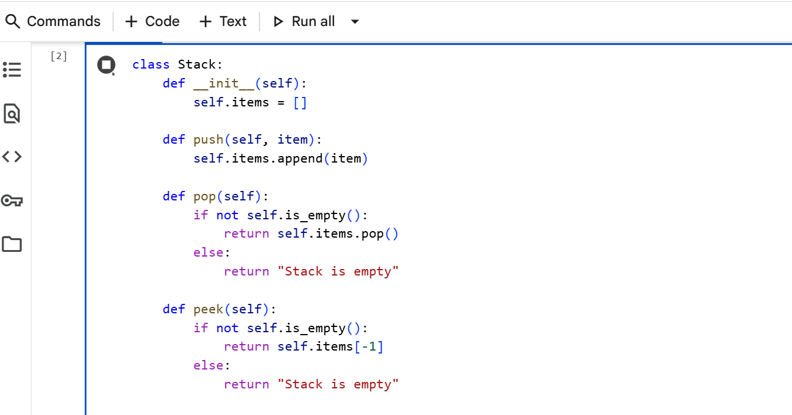  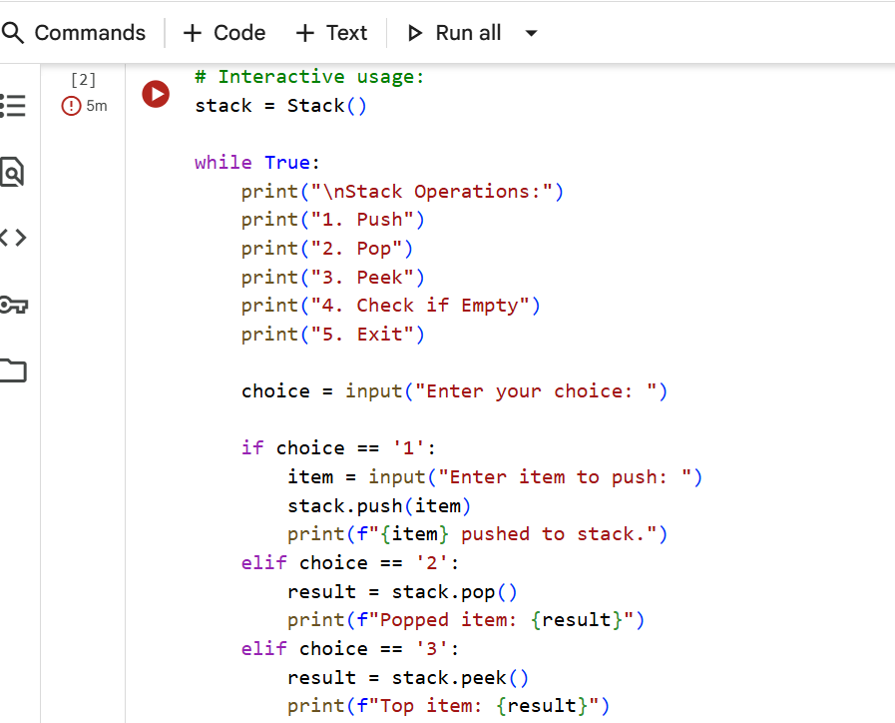  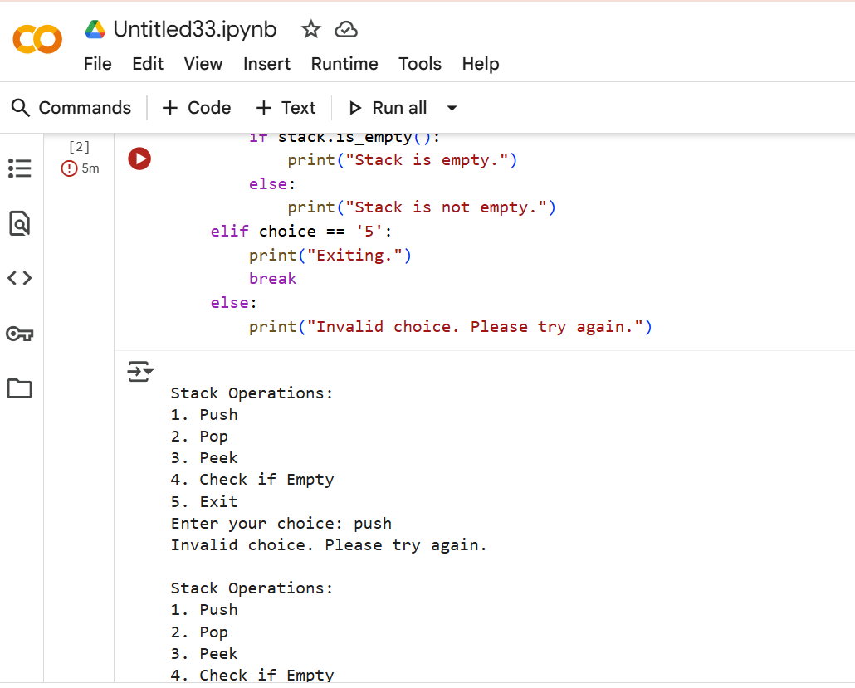  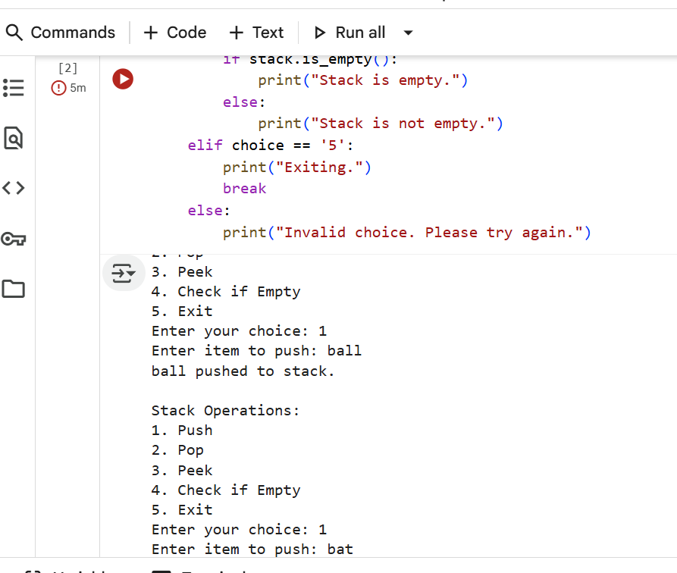  Task Description #2 – Queue Implementation  Task: Use AI to implement a Queue using Python lists.  Sample Input Code:  class Queue:  pass  Expected Output:  - FIFO-based queue class with enqueue, dequeue, peek, and size methods.  PROMPT:WRITE A PYTHON CODE TO IMPLEMENT A QUEUE USING PYTHON LIST FROM THE USER INPUT AND THAT QUEUE IS BASED IN THE FIFO WITH ENQUEUE, DEQUEUE PEEK, AND SIZE METHODS  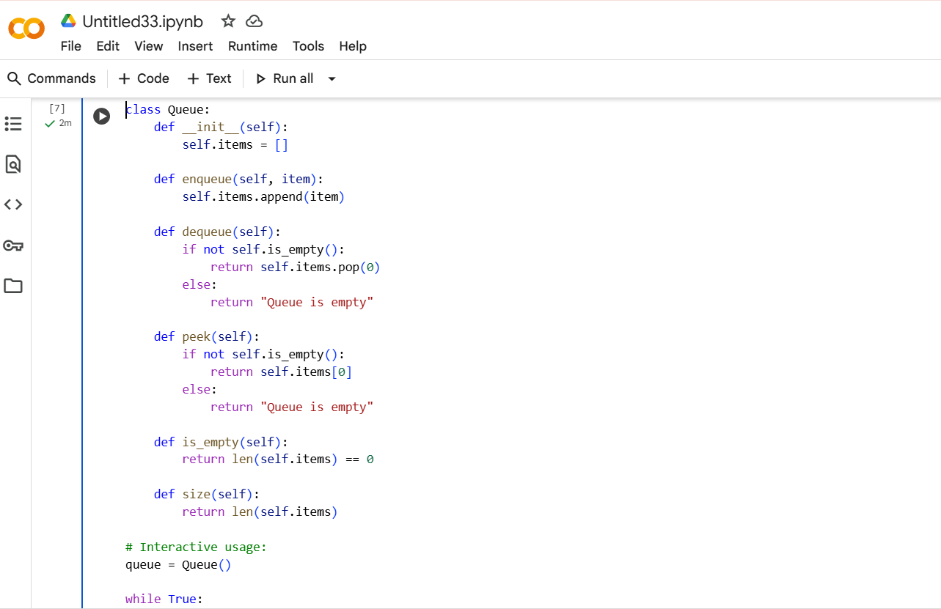  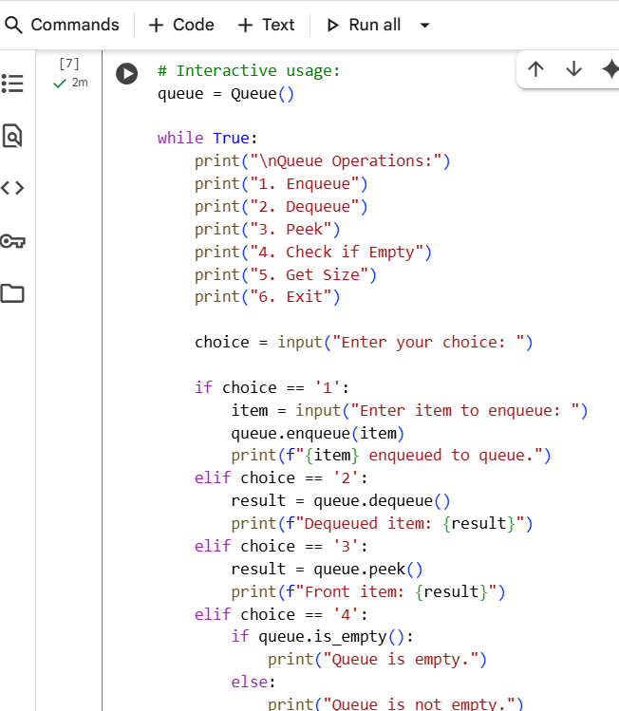  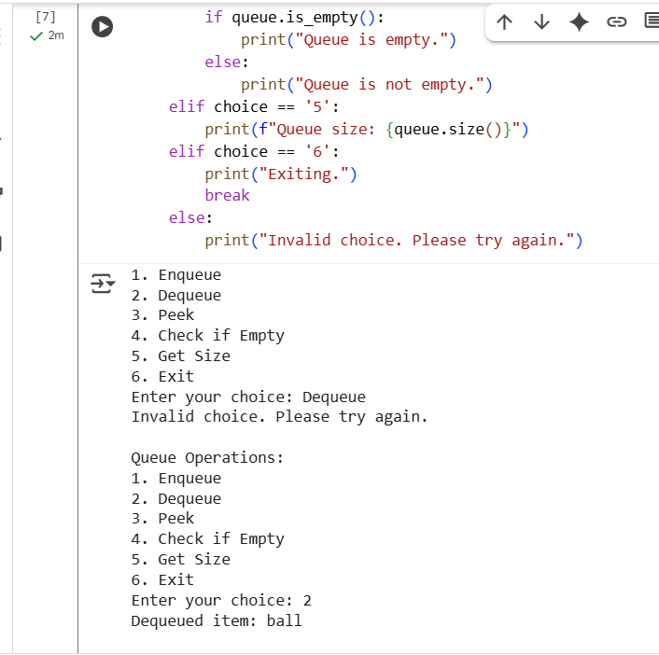  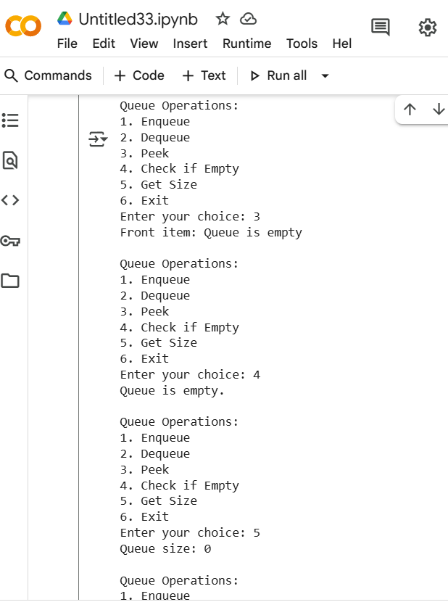  Task Description #3 – Linked List  Task: Use AI to generate a Singly Linked List with insert and display methods.  Sample Input Code:  class Node:  pass  class LinkedList:  pass  Expected Output:  - A working linked list implementation with clear method documentation.  PROMPT:WRITE A PYTHON CODE TO GENERATE A SINGLY LINKED LIST FROM USER INPUT WITH INSERT AND DISPLAY METHODS  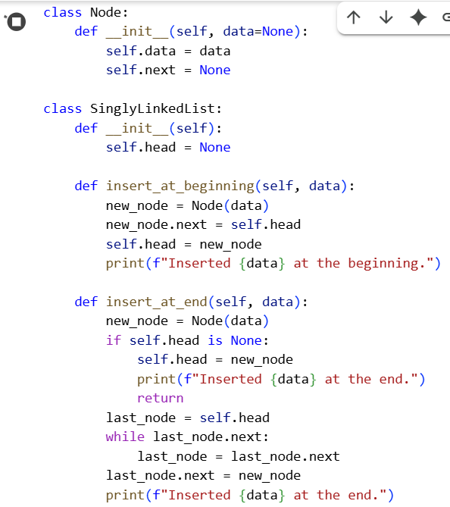  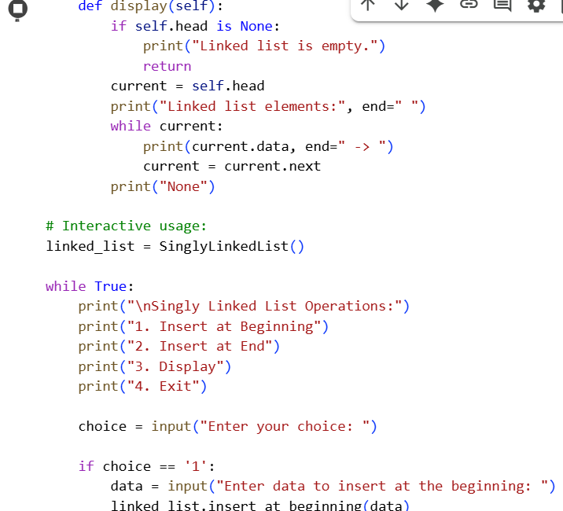  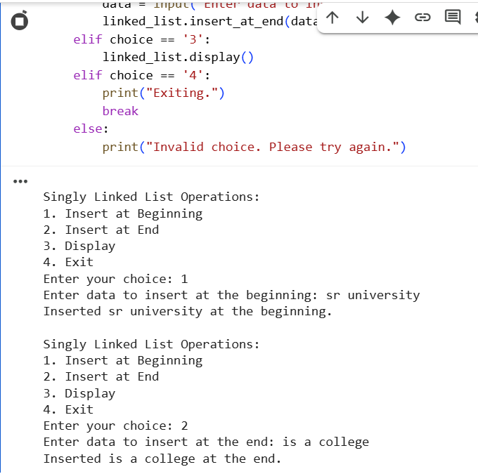  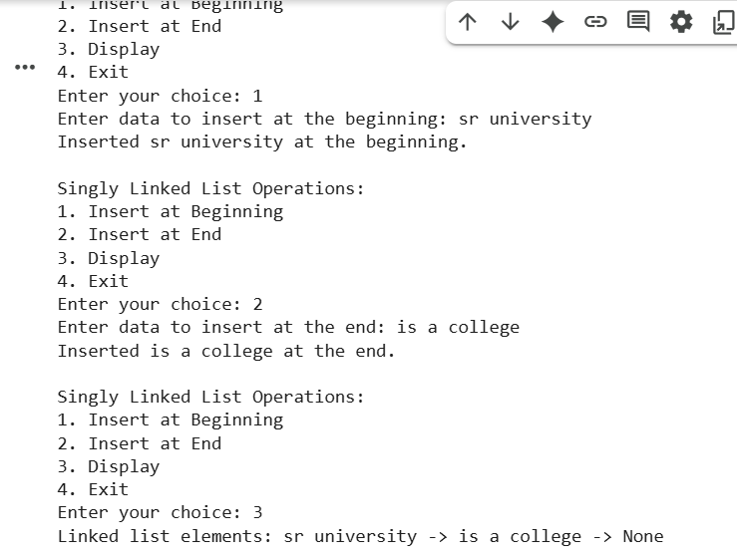  Task Description #4 – Binary Search Tree (BST)  Task: Use AI to create a BST with insert and in-order traversal methods.  Sample Input Code:  class BST:  pass  Expected Output:  - BST implementation with recursive insert and traversal methods.  PROMPT:CREATE A BINARY SEARCH TREE WITH INSERT AND IN_ORDER METHODS FROM USER INPUT  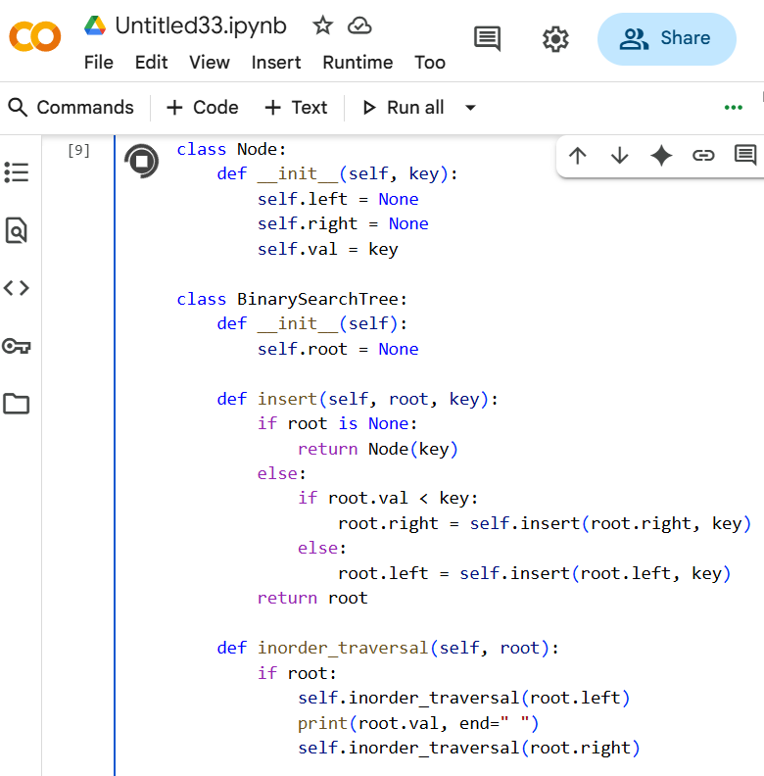  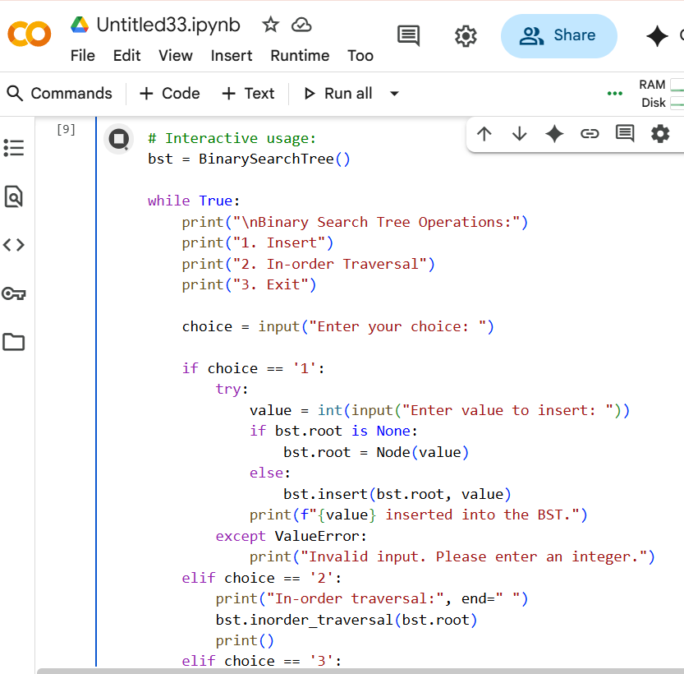  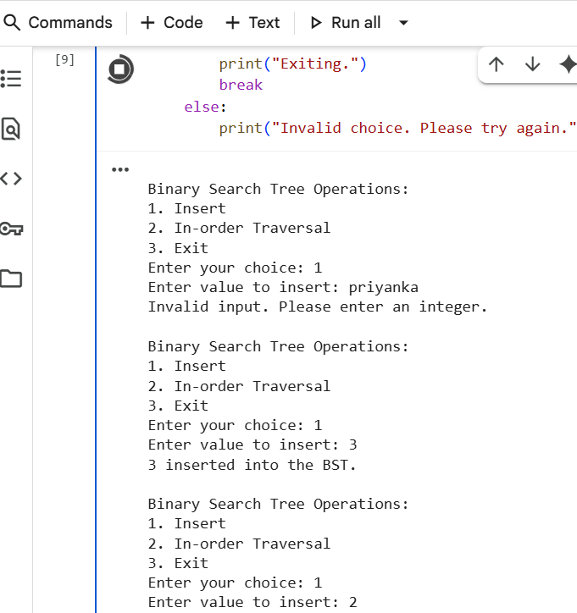  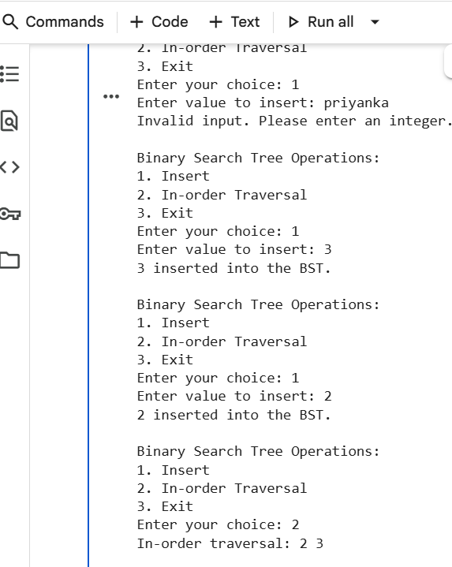  Task Description #5 – Hash Table  Task: Use AI to implement a hash table with basic insert, search, and delete methods.  Sample Input Code:  class HashTable:  pass  Expected Output:  - Collision handling using chaining, with well-commented methods.  PROMPT:GENERATE A PYTHON CODE FOR HASH TABLE WHICH INCLUDES INSERT, SEARCH, AND DELETE METHODS FROM USER INPUT  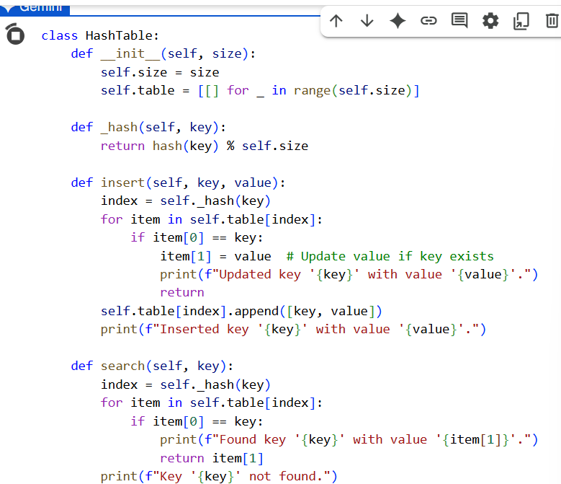  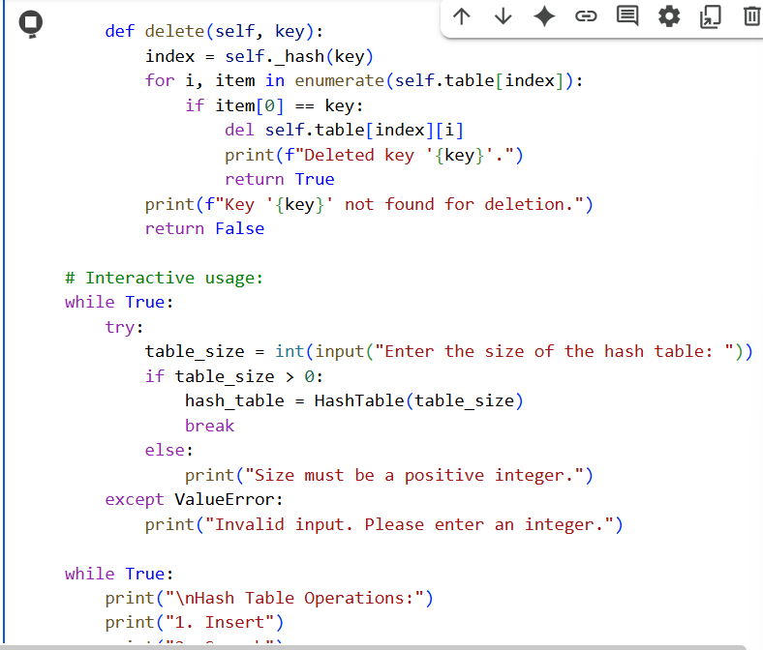  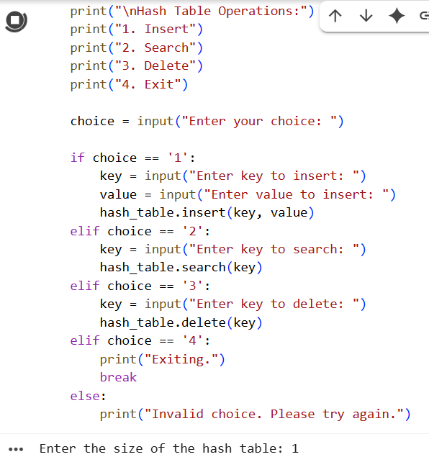  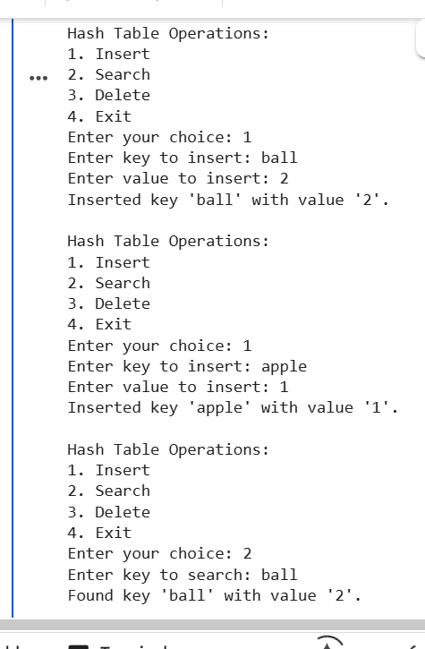  Task Description #6 – Graph Representation  Task: Use AI to implement a graph using an adjacency list.  Sample Input Code:  class Graph:  pass  Expected Output:  - Graph with methods to add vertices, add edges, and display connections.  PROMPT:WRITE A PYTHON CODE TO IMPLEMENT A GRAPH USING A ADJACENCY LIST AND GRAPH WITH METHODS TO ADD VERTICES, EDGES, AND DISPLAY  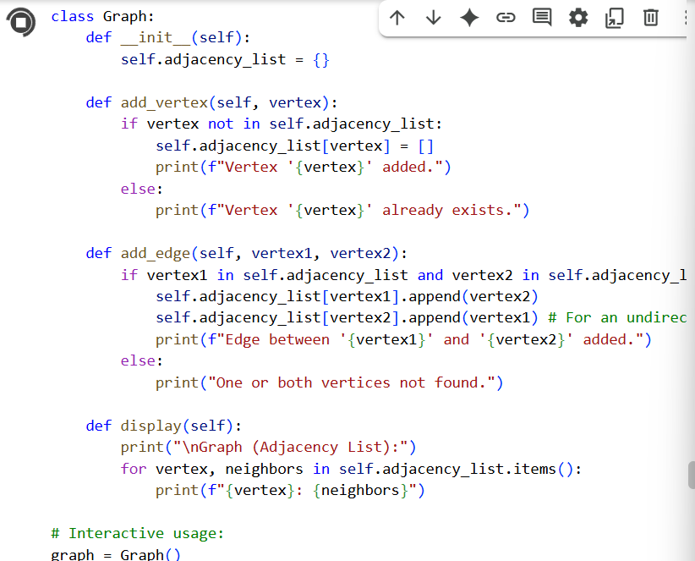  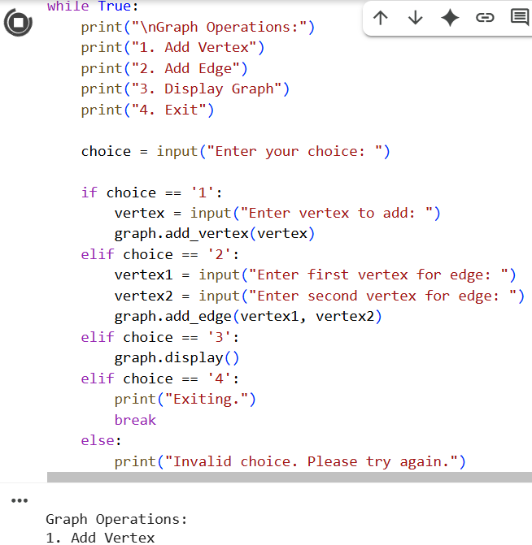  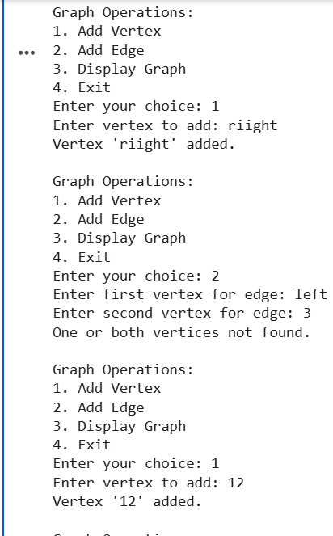  Task Description #7 – Priority Queue  Task: Use AI to implement a priority queue using Python’s heapq module.  Sample Input Code:  class PriorityQueue:  pass  Expected Output:  - Implementation with enqueue (priority), dequeue (highest priority), and display methods.  PROMPT:GENERATE A PYTHON CODE TO IMPLEMENT A PRIORITY QUEUE USING PYTHONS HEAPQ MODULE AND METHODS LIKE ENQUEUE, DEQUEUE, AND DISPLAY METHODS  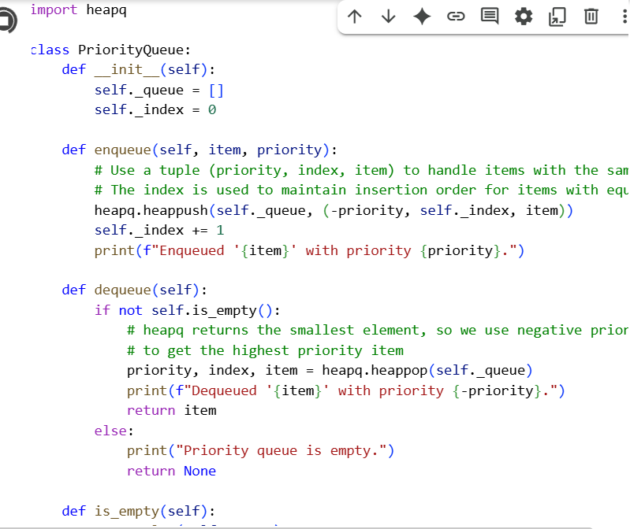  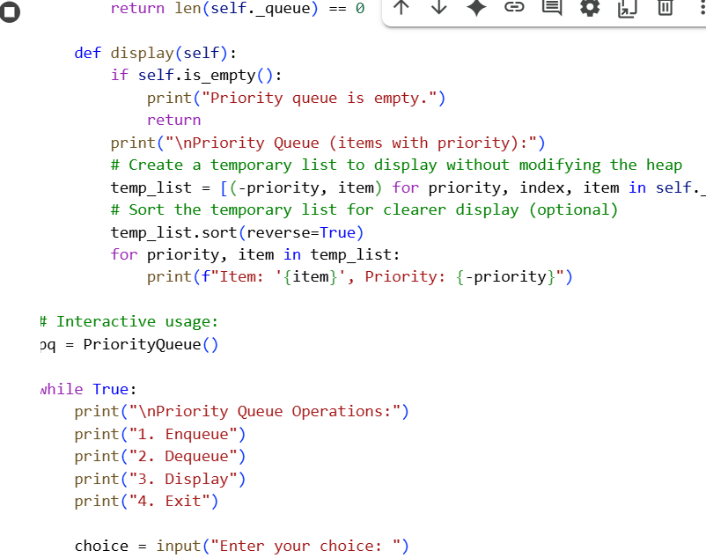  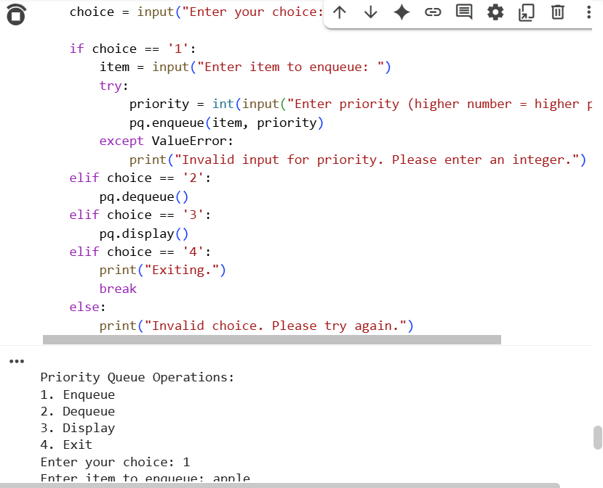  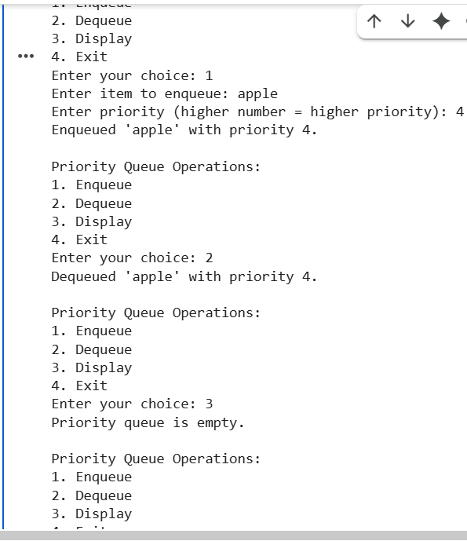  Task Description #8 – Deque  Task: Use AI to implement a double-ended queue using collections.deque.  Sample Input Code:  class DequeDS:  pass  Expected Output:  - Insert and remove from both ends with docstrings.  PROMPT:WRITE A PYTHON CODE FOR TO IMPLEMENT A DOUBLE ENDED QUEUE USING COLLECTIONS DEQUEUE WITH INSERT AND REMOVE FROM BOTH ENDS WITH DOCSTRINGS  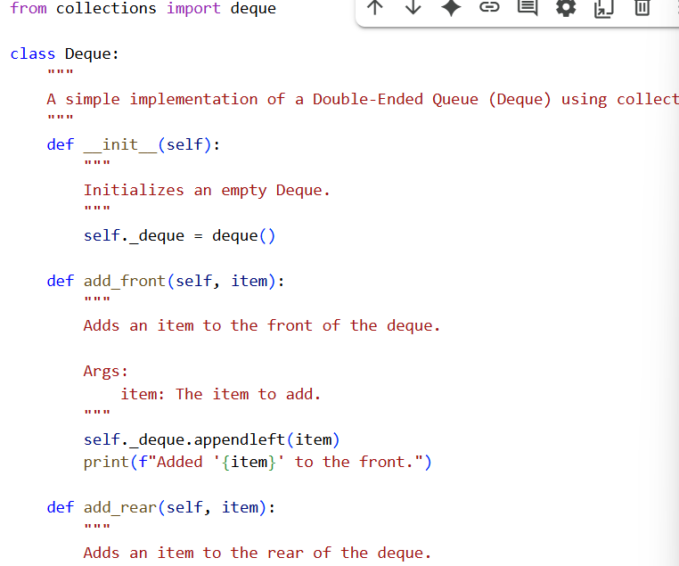  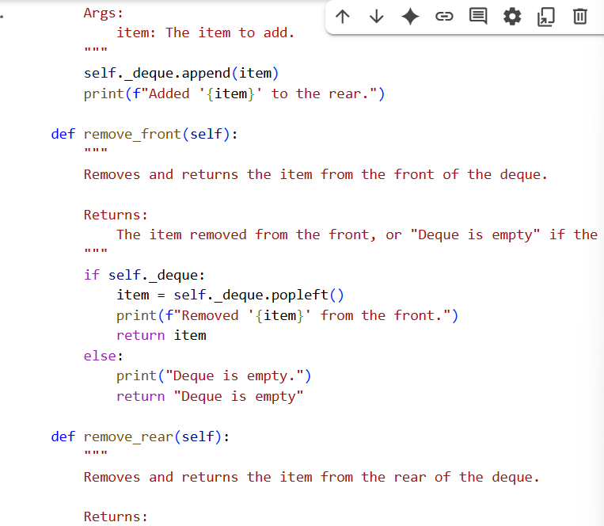  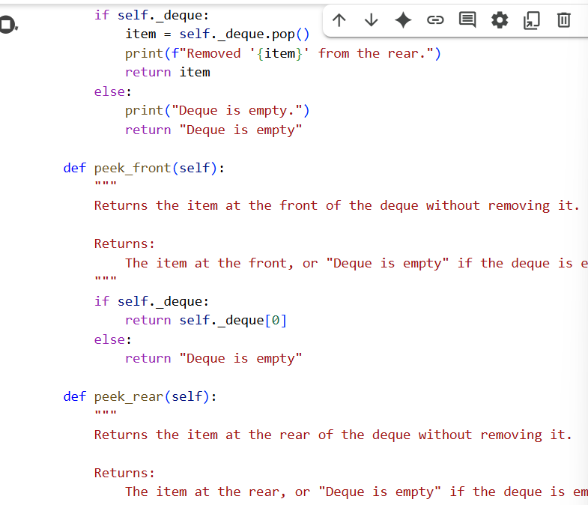  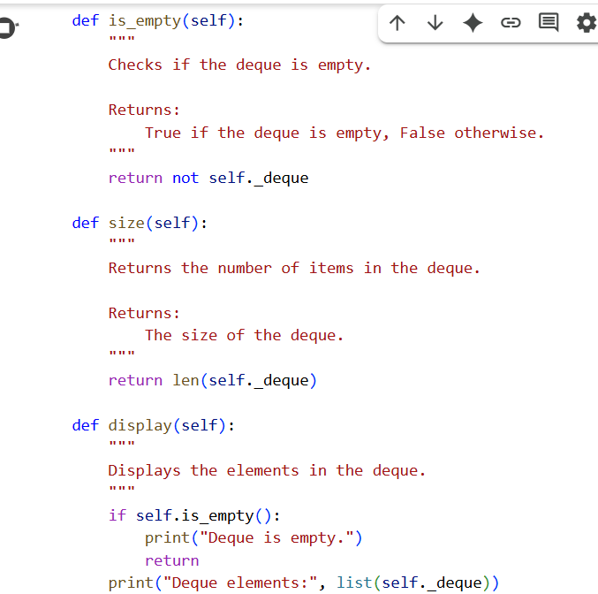  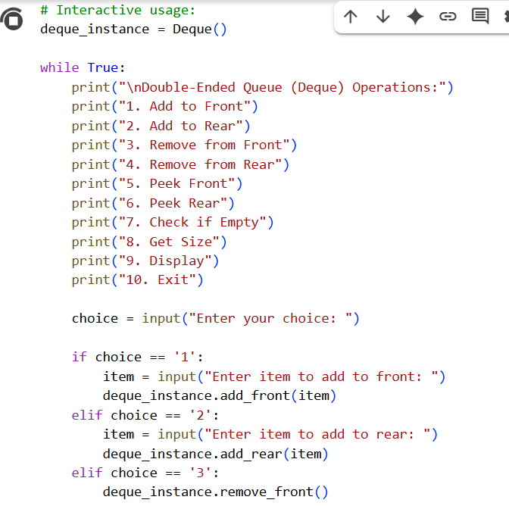  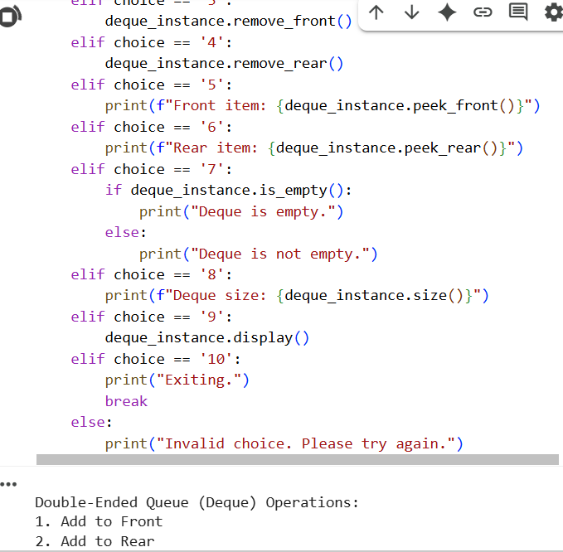  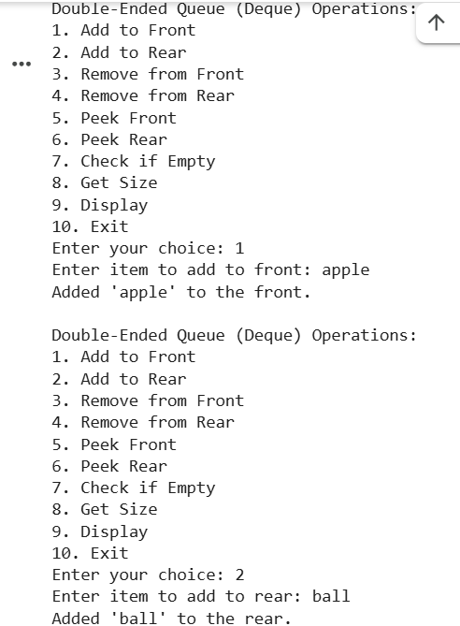  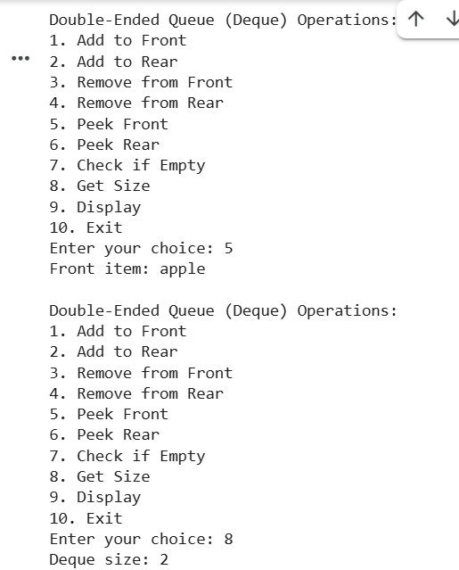  Task Description #9 – AI-Generated Data Structure Comparisons  Task: Use AI to generate a comparison table of different data structures (stack, queue, linked list, etc.) including time complexities.  Sample Input Code:  # No code, prompt AI for a data structure comparison table  Expected Output:  - A markdown table with structure names, operations, and complexities.  PROMPT:GENERATE A PYTHON CODE FOR EXAMPLE TAKING ONE, COMPARE WITH DIFFERENT DATA  STRUCTURES LIKE STACK, QUEUE,LINKED LIST ETC  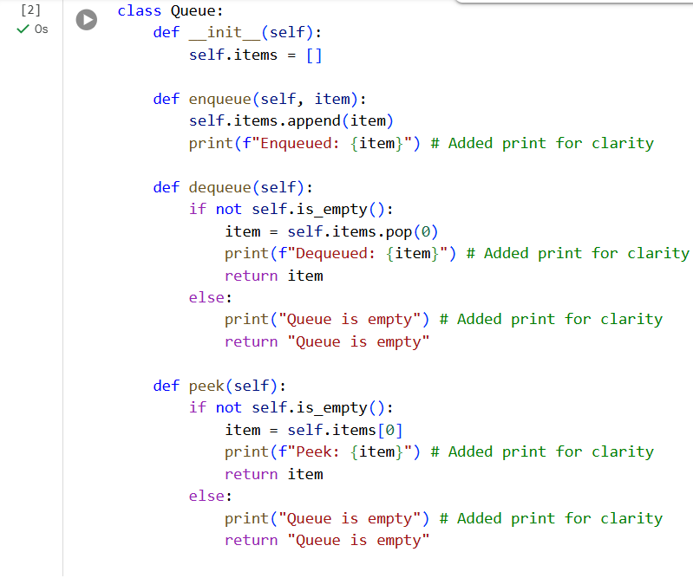  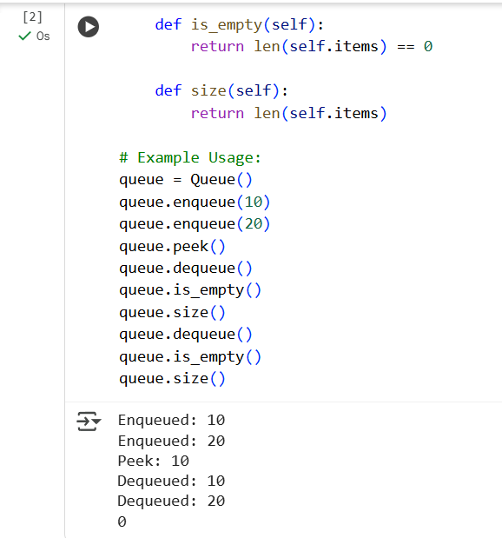  Task Description #10 Real-Time Application Challenge – Choose the Right Data Structure  Scenario:  Your college wants to develop a Campus Resource Management System that handles:  - Student Attendance Tracking – Daily log of students entering/exiting the campus.  - Event Registration System – Manage participants in events with quick search and removal.  - Library Book Borrowing – Keep track of available books and their due dates.  - Bus Scheduling System – Maintain bus routes and stop connections.  - Cafeteria Order Queue – Serve students in the order they arrive.  Student Task:  - For each feature, select the most appropriate data structure from the list below:  - Stack  - Queue  - Priority Queue  - Linked List  - Binary Search Tree (BST)  - Graph  - Hash Table  - Deque  - Justify your choice in 2–3 sentences per feature.  - Implement one selected feature as a working Python program with AI-assisted code generation.  Expected Output:  - A table mapping feature → chosen data structure → justification.  - A functional Python program implementing the chosen feature with comments and docstrings.  ✅ Deliverables (For All Tasks)  - AI-generated prompts for code and test case generation.  - At least 3 assert test cases for each task.  - AI-generated initial code and execution screenshots.  - Analysis of whether code passes all tests.  - Improved final version with inline comments and explanation.  - Compiled report (Word/PDF) with prompts, test cases, assertions, code, and output.  PROMPT: my college wants to develop a campus resource management system that handles the student attendence tracking, event registration system, library book borrowing, bus scheduling system, cafeteria order queue, here for each feature select the data struture like stack, queue, priority queue, linkd list, binary search tree, graph, hashtable, deque now generate a python code which includes all this from user input  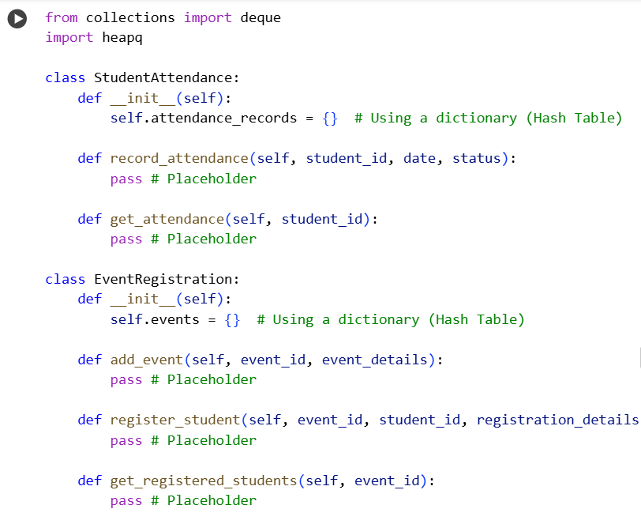  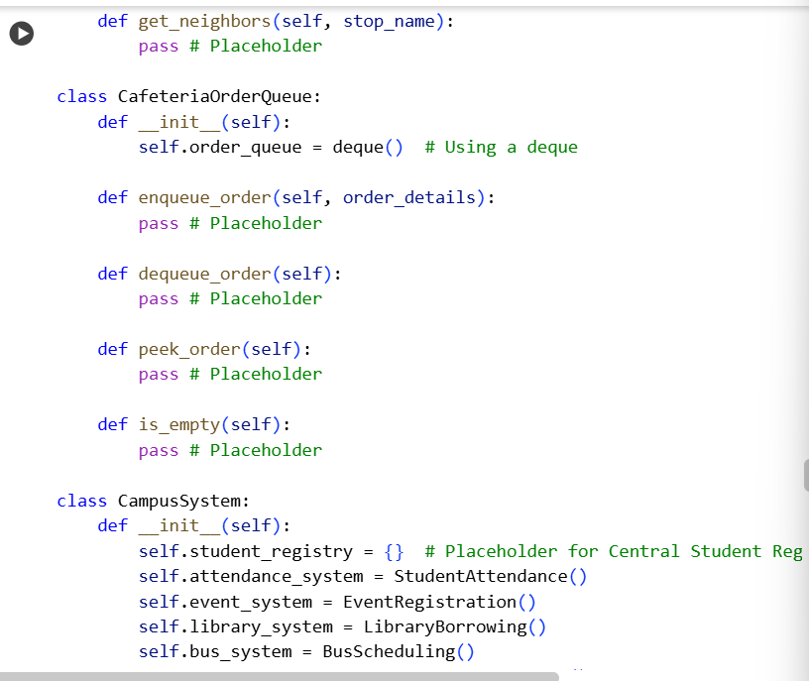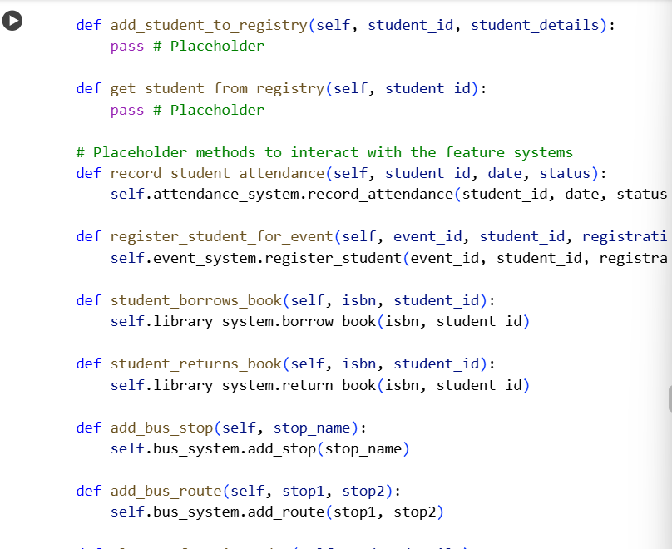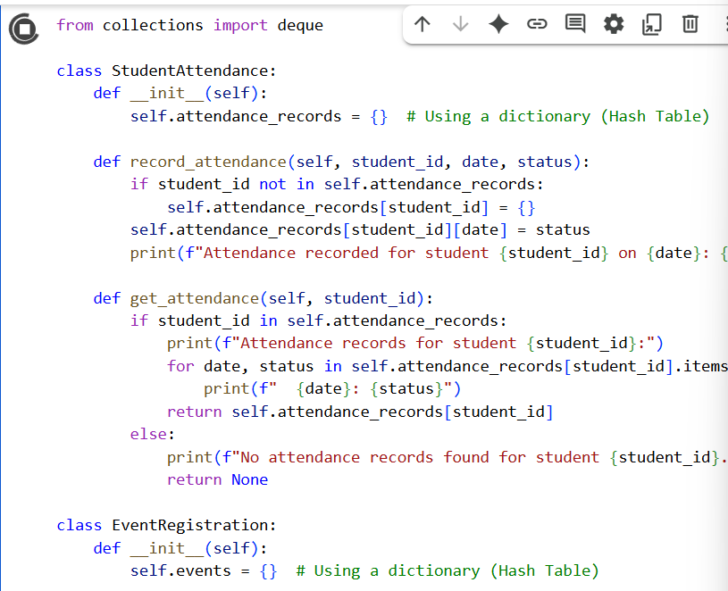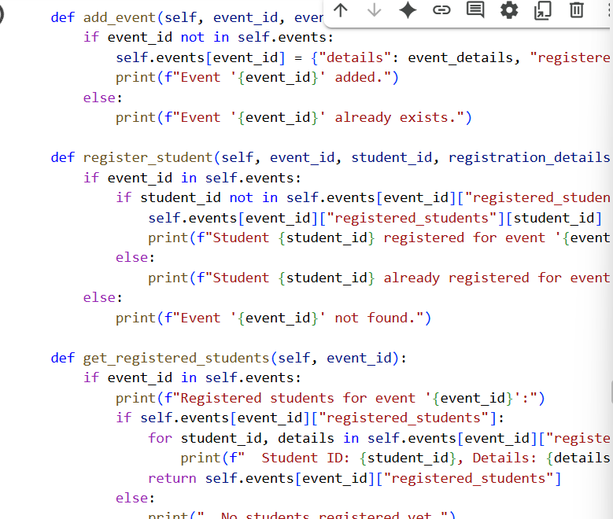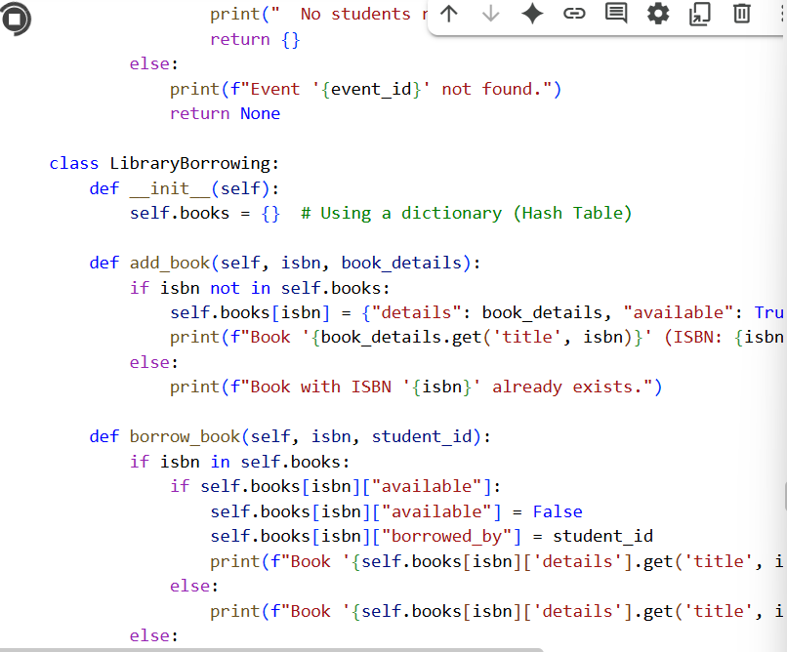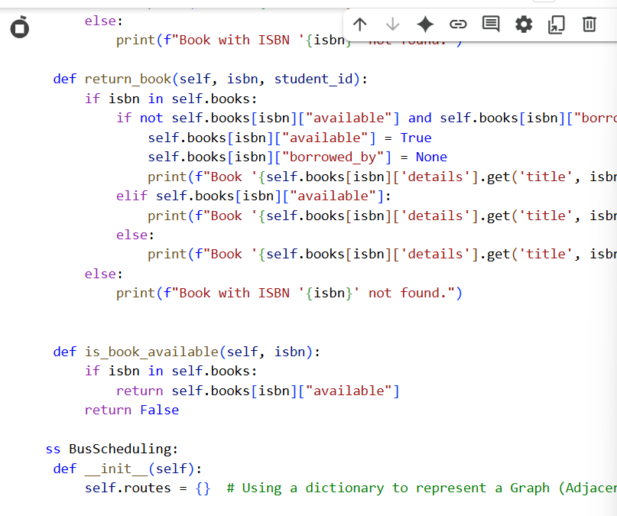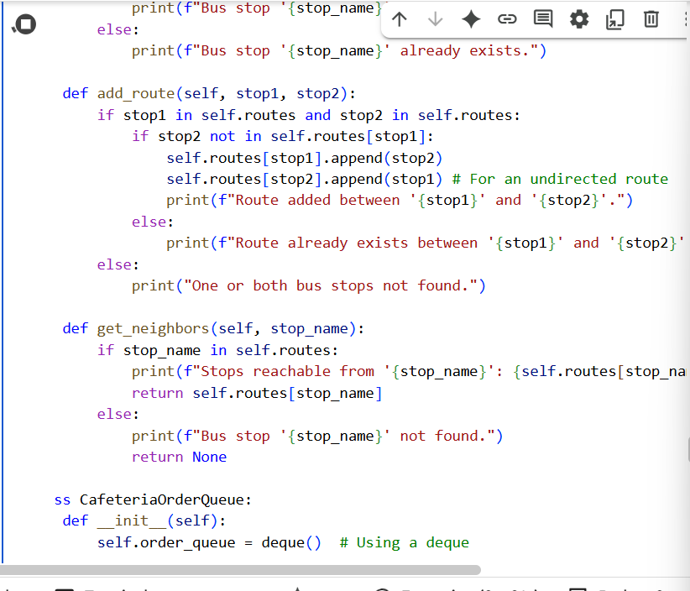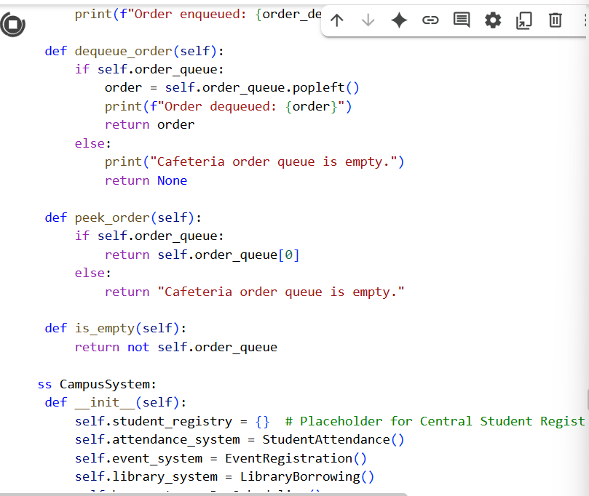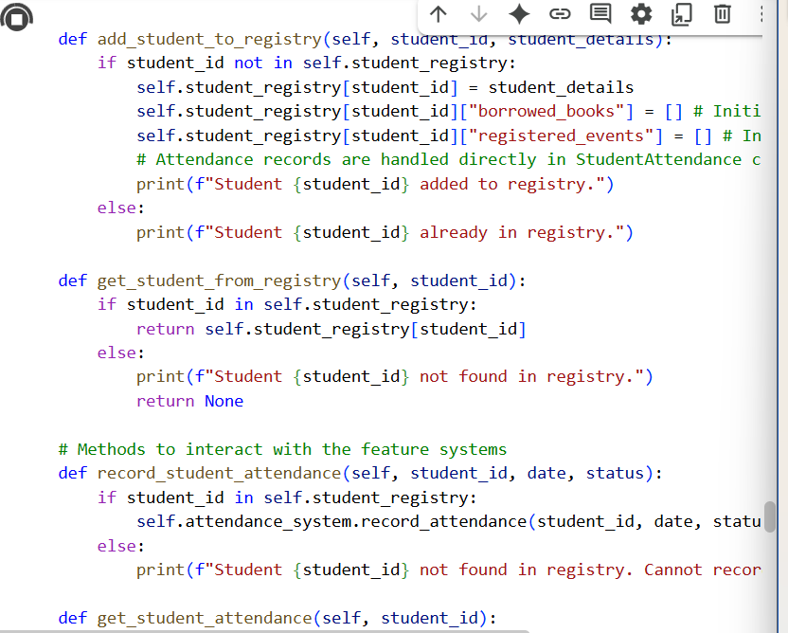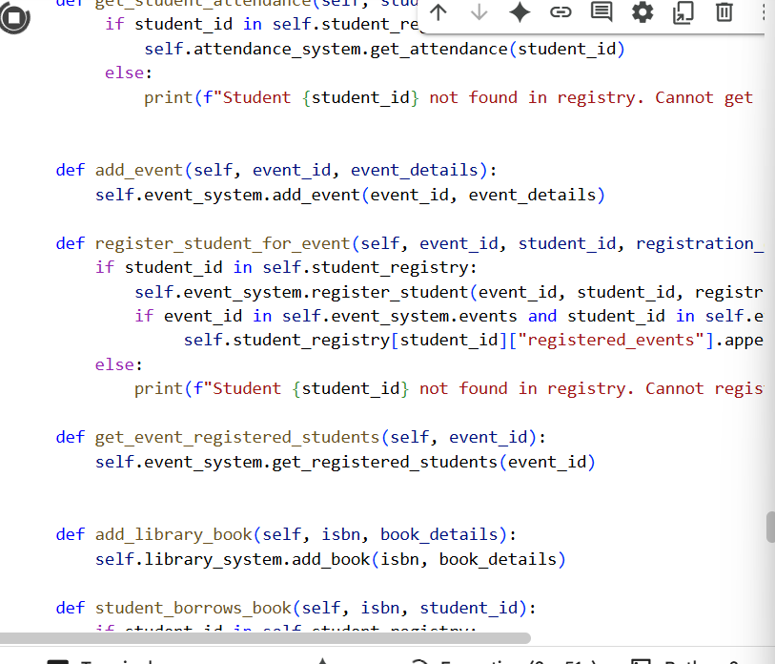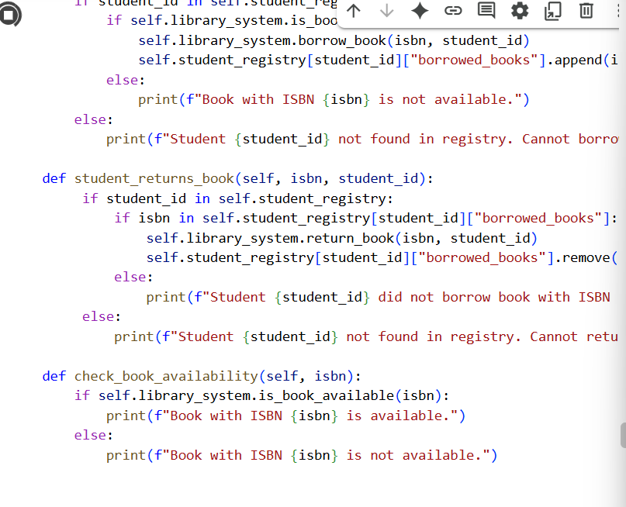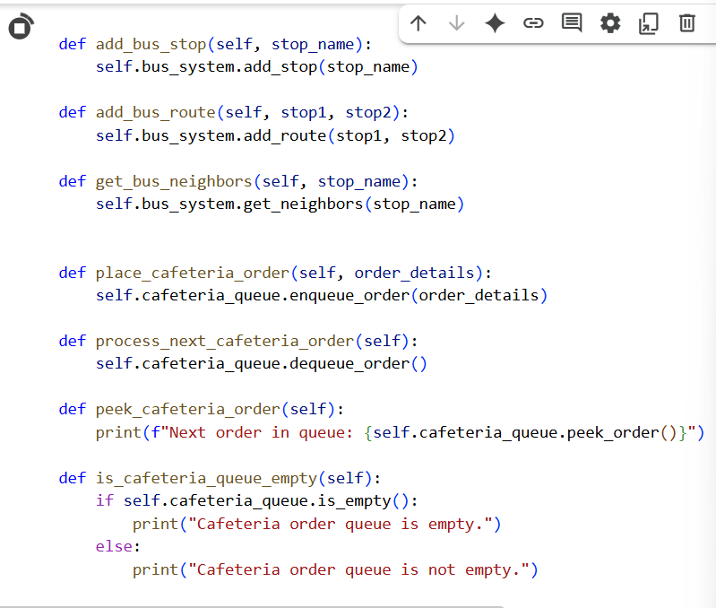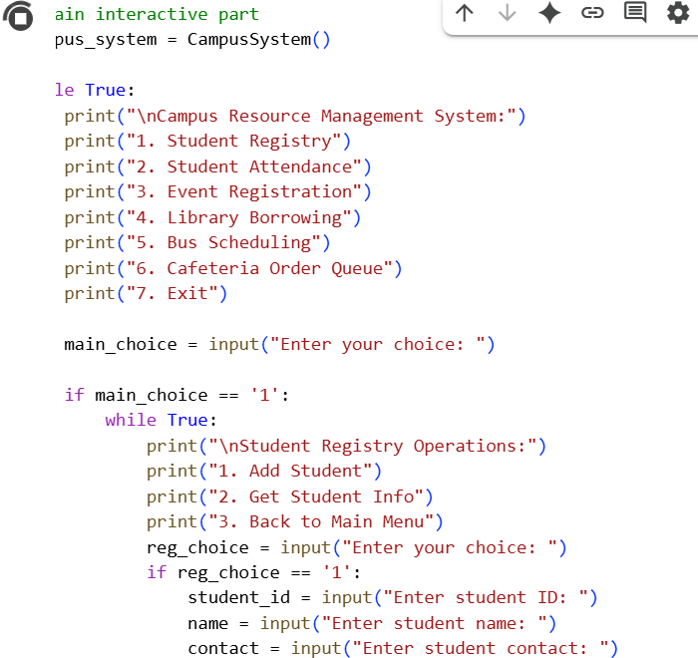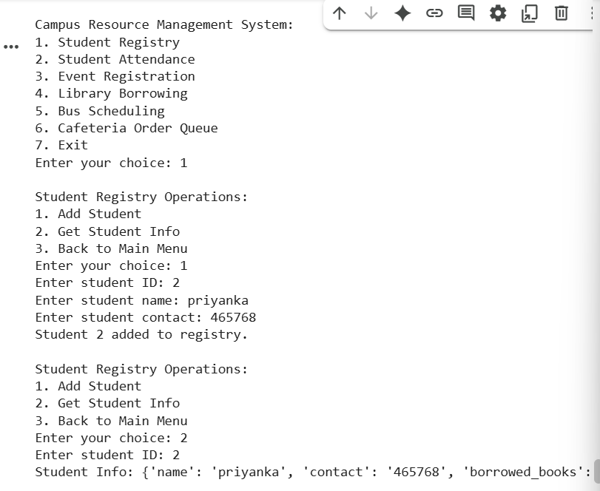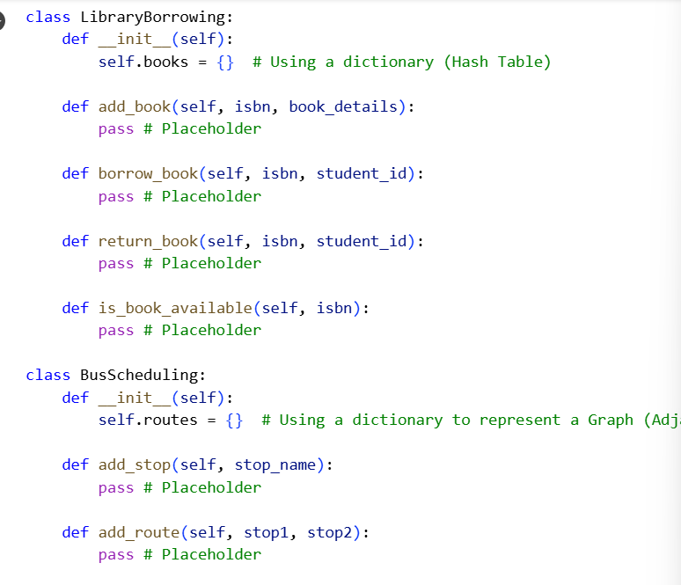 |  |  |  |  |  | Week6 - Monday

